HandsMen Threads: Elevating the Art of Sophistication in Men’s Fashion

ABSTRACT

This project focuses on building a Salesforce CRM application called HandsMen Threads, designed to manage customer information, product data, inventory, orders, and marketing activities. The system uses custom objects, validation rules, Apex Triggers, and Salesforce Flows to automate processes and ensure accurate data entry. A customized Lightning App provides easy navigation, while reports and dashboards give clear insights into sales and inventory performance. Overall, HandsMen Threads demonstrates how Salesforce can be used to create an efficient and user-friendly business management solution.

OBJECTIVE

The main objective of this project is to develop and implement a customized CRM solution for HandsMen Threads that efficiently organizes key business data, automates processes, and supports essential operations. Specifically, the project aims to:

- Create custom objects to manage customers, products, orders, and inventory

- Build a Lightning App that centralizes all important tabs and features

- Apply validation rules to maintain accurate and consistent data

- Implement Apex Triggers and Salesforce Flows to automate tasks such as inventory updates and notifications

- Configure reports and dashboards to provide clear business insights

- Demonstrate how Salesforce tools can streamline operations and reduce manual work

TECHNOLOGY DESCRIPTION

Salesforces
Salesforce is a cloud-based Customer Relationship Management (CRM) platform that helps businesses manage customer data, automate workflows, track sales and marketing activities, and improve overall efficiency and decision-making.

Custom Object
In Salesforce, custom objects are like database tables created to store and manage business-specific data, such as customers, products, orders, or inventory.
• Customer__c – stores customer information
• Product__c – stores product details
• Order__c – stores order records
Tabs
Tabs in Salesforce are used to display object data in the user interface, making it easy to view and manage records. For example, a Product__c tab allows users to quickly access and manage product information.
Custom App
A personalized Salesforce application that organizes objects, tabs, and features for easy access.
Profiles
Define user permissions and control what users can see and do in Salesforce.
Roles
Establish hierarchy and data access based on a user’s position in the organization.
Permission Sets
Grant additional permissions to users without changing their profiles.
Validation Rules
Ensure data entered meets specific criteria before saving records.
Email Template
Predefined email formats used for consistent communication, such as an “Order Confirmation” template.
Email Alerts
Automated emails sent when specific actions or conditions occur, such as notifying a customer when their loyalty level changes.
Flows
Automate processes and guide users through tasks without code, such as triggering an email alert when a new order is created.
Apex
Salesforce’s programming language used to create custom logic and automate actions, such as updating the Total_Amount__c in orders and reducing inventory stock.

DETAILED EXECUTION OF THE PROJECT PHASES

- Developer Org Set up
• I created my Salesforce Developer Org using the official signup page.
• After registering, I verified my email and set my password.
• Once the account was confirmed, I was able to log in and access the Salesforce Setup page.

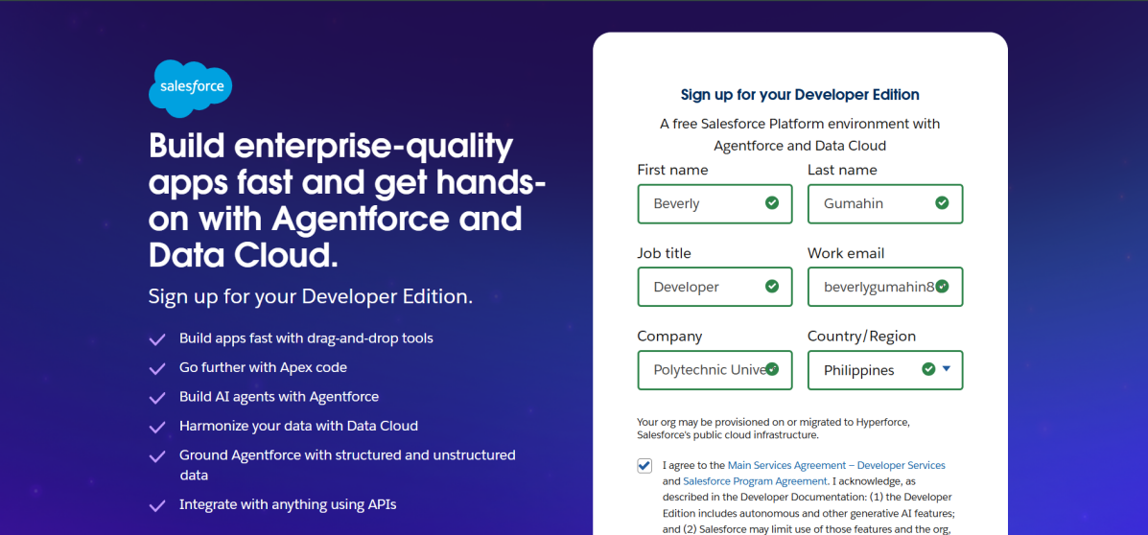

- Custom Object Creation

Five custom objects were set up to organize and store the main data needed for the project:

HandsMen Customer – stores customer information

HandsMen Product – stores product details

Inventory – tracks available stock

Marketing Campaign – stores campaign-related data

Steps Followed:

- Navigated to Setup and opened the Object Manager.

- Filled in the required details for each custom object.

- Saved the objects and created individual tabs so they can be easily accessed in the app.

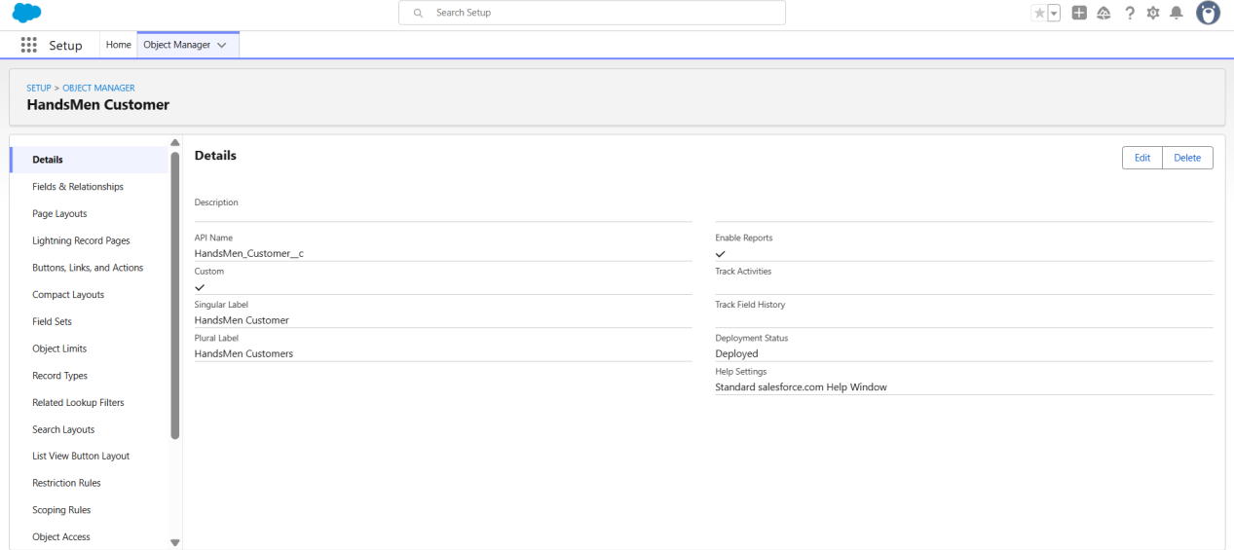

- Creating the Lightning App
• A custom Lightning App was created to group all the objects and tabs needed for the project.
• The app was customized with the required navigation items so users can easily access Customers, Products, Orders, Inventory, and Campaigns.
- Validation Rules

To maintain correct data entry and apply the needed business rules, the following validation rules were added:

- Order Object: Blocks saving when Total_Amount__c is less than or equal to 0.
Error Message: “Please enter a valid amount.”

- Customer Object: Ensures that the email field contains “@gmail.com”.
Error Message: “Please enter a valid Gmail address.”

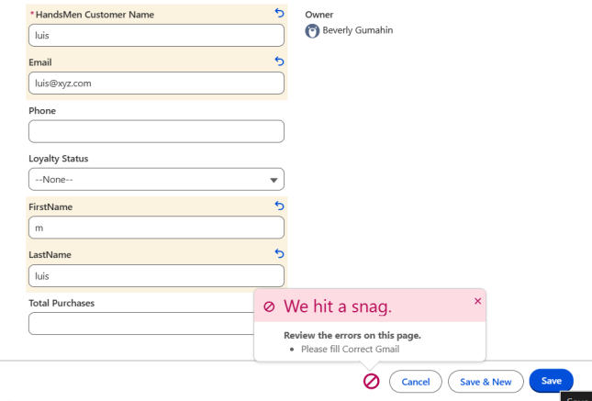

- User Role & Profile Setup

- Clone the Standard User profile to new profile named Platform 1 and added access to necessary custom object.

- Created roles for different departments:
Sales Manager, Inventory Manager, Team

- User Creation

User were created in Saleforce and assigned appropriate roles and profiles to reflect their responsibilites:

- Niklaus Mikaelson - Assigned the Sales role

- Kol Mikaelson - Assigned the Inventory role

- These roles-based assignments help enforce proper data access and process control within the system.

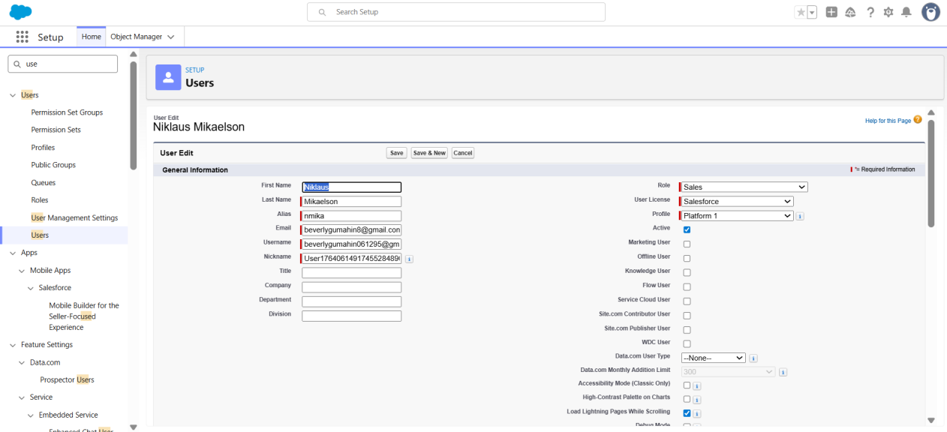

- Email Template & Alerts

Created three email templates:

- Order Confirmation - Sent on order status = Confirm

- Low Stock Alert - Sent when Inventory < 5 units

- Loyalty Program Email - Sent when loyalty status changes

Corresponding Email Alerts were created using these templates and linked to automation flows.

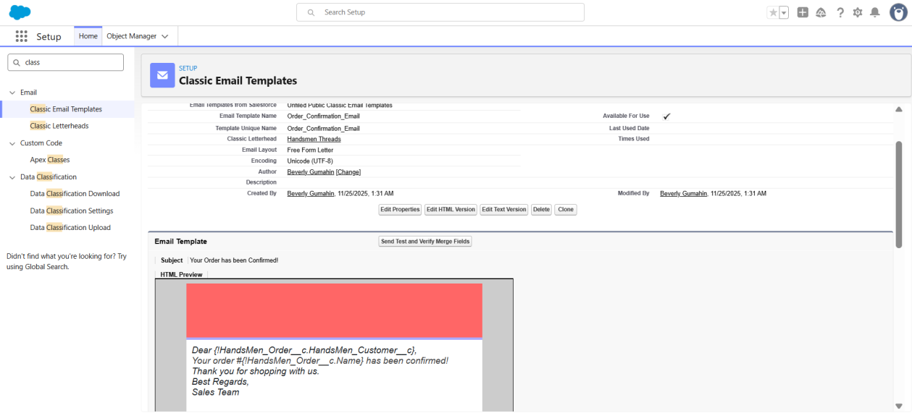

- Flow Implementation

- Order Confirmation Flow

- Triggered when an order is updated to Confirmed.

- Sends an Order Confirmation email to the related customer.

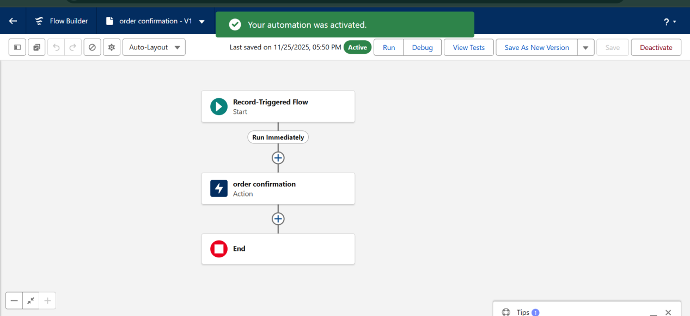

- Stock Alert Flow

- Triggered when Inventory stock drops below 5

- Send Low Stock email to Inventory Manager.

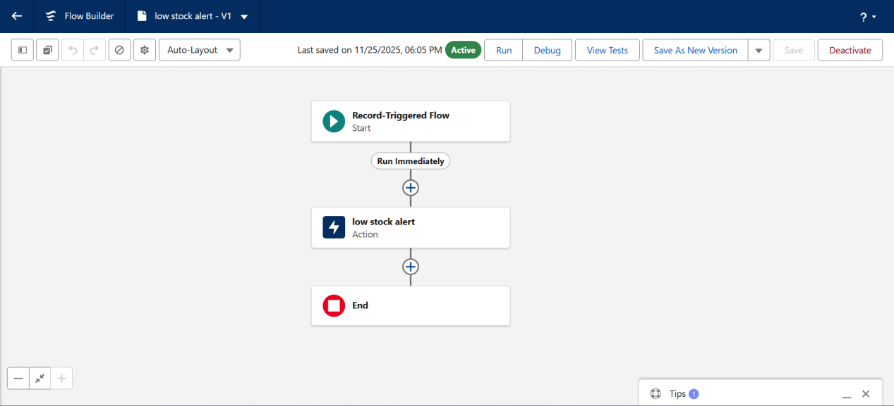

- Scheduled Flow: Loyalty Update

- Runs daily at midnight.

- Loops through customers and updates their Loyalty Status based on total purchases.

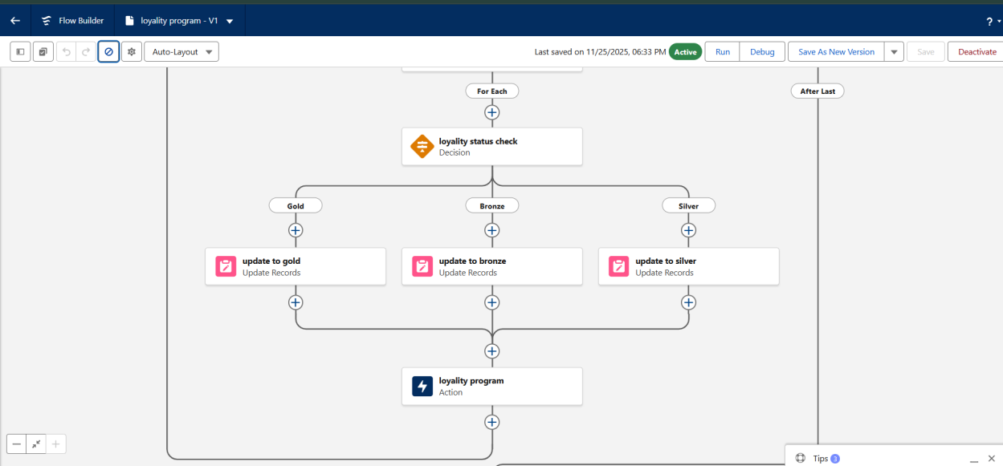

- Apex Triggers

- Order Total Trigger: Auto-calculates Total Amount based on quality and unit price.

- Stock Deduction Trigger: Reduces stock when an order is placed.

- Loyalty Status Trigger: Updates Loyalty Status based on total purchases.

PROJECT EXPLANATION WITH REAL-WORLD EXAMPLE

Let’s walk through it like a real customer interaction.

1. Customer Registration

- A customer named Marcus Reynoso visits the online shop.

- In Salesforce: A new record is created in Customer__c with his details.

- Validation Rule:
Email must contain Marcus@gmail.com.

- Product Setup

The admin sets up products inside Product__c:

- Canvas Jacket

- Slim-Fit Cargo Pants

- Eco Water Bottle

Each product includes:

- Price

- Category

- Description

- Supplier

Inventory records track available stock for each item.

- Order Placement

Marcus purchases:

- 1 × Canvas Jacket (₱850)

- 2 × Eco Water Bottle (₱199 each)

A new Order__c record is created.

Total_Amount__c = (1 × 850) + (2 × 199) = ₱1,248

- Inventory Update

An Apex Trigger reduces the stock:

- Jacket stock −1

- Water Bottle stock −2

Validation Rule:
Prevents saving if stock is less than 0 to avoid negative inventory.

- Loyalty Program

Marcus’ accumulated purchases are checked:

Based on the value:

Below 500 → Bronze

₱500-₱1000 → Silver

₱1000 → Gold

He becomes an Gold Customer because his total reached ₱1,248.

- Email Notifications

- When a new order is placed or loyalty status is updated.

- Flow + Email Alert is triggered.

- Elijah gets an email:

“Thanks for your purchase! Your loyalty status is now Silver.”

- Users and Roles

Saleforce users like store staff are created:

- Niklaus Mikaelson - Sales Role (Platform 1 Profile)

- Kol Mikaelson - Inventory Role (Platform 1 Profile)

SCREENHOTS

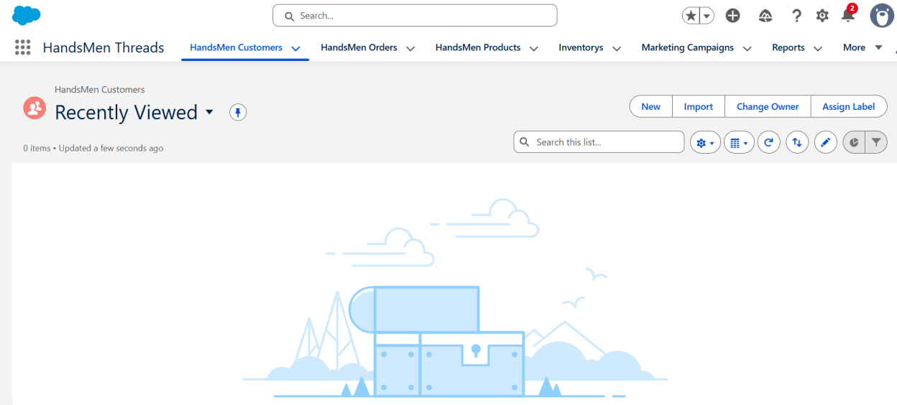

Fig: Custom App for HandsMen Threads

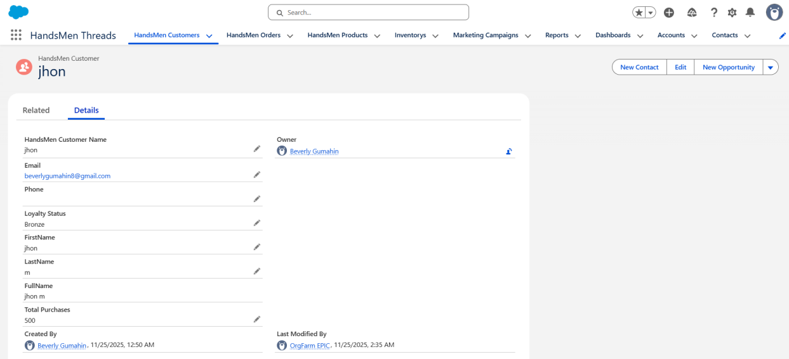

Fig: Customer Creation in HandsMen Threads

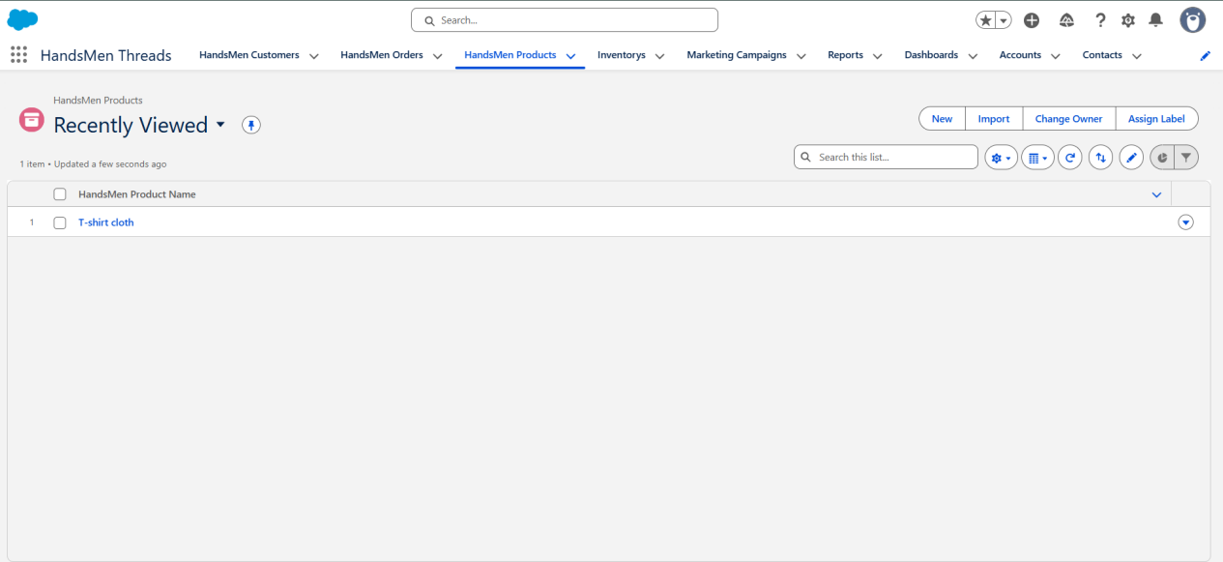
Fig: Product in HandsMen Threads

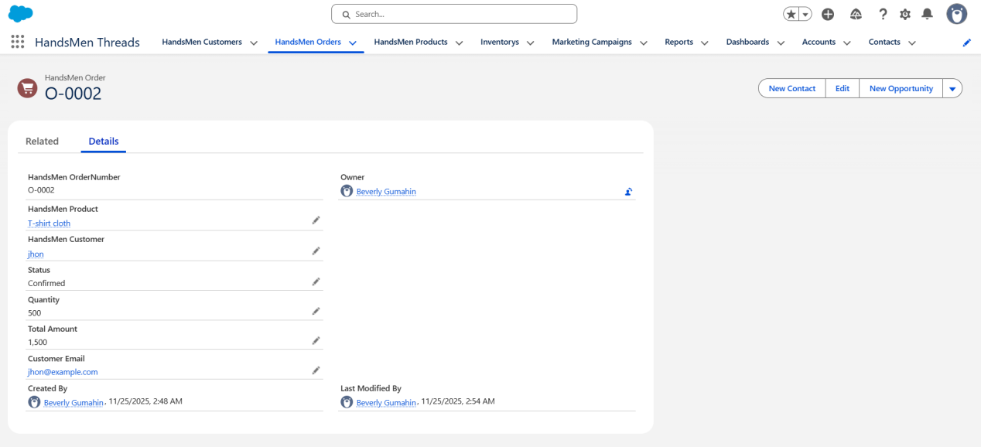

Fig: Order Confirmation

CONLUSION

The HandsMen Threads Salesforce CRM project effectively illustrates how Apex logic, automation tools, validation rules, and custom objects can cooperate to optimize business processes. The system significantly increases accuracy and efficiency by managing products and inventories, organizing customer data, automating order processing, and producing real-time insights through dashboards and reports. The project also emphasizes the benefits of utilizing Salesforce as a consolidated platform for customer engagement, inventory control, and sales. All things considered, HandsMen Threads demonstrates that even a tiny retail company can profit from a well-thought-out CRM system that improves efficiency, minimizes manual labor, and facilitates improved decision-making.

Future Scope:

- Connectivity to Payment Gateways
Give clients the option to pay online and have transactions automatically recorded in Salesforce.
2. Extension for Mobile Apps
Create a mobile-friendly design or customize the Salesforce Mobile App to track inventory and sales while on the go.
3. AI-Powered Suggestions
Use Einstein AI to discover high-value clients, forecast low stock, and make product recommendations.
4. Extended Loyalty Initiative
For a more engaging loyalty program, include point-based awards, coupons, and customer tier perks.
5. Support for Multiple Stores or Franchises
Make it possible to track individual inventory, several branches, and combined reporting.

